What is a network/what is networking?

Good networking is not smarmy and does not “use” other people. An effective networker participates, which includes offering help and information to other people while you are informing other people about what you do and where you are.

 |  |  | smarm·y – from Dictionary.com  ˈsmɑrmi Show Spelled[smahr-mee]  –adjective, smarm·i·er, smarm·i·est.  excessively or unctuously flattering, ingratiating, servile, etc.: the emcee with the smarmy welcome.  Origin:  1905–10; smarm, variant of dial. smalm to smear, make slick  —Related forms  smarm·i·ly, adverb

Why Network?
You learn new things.
New people learn about you.
It helps create opportunities.

Your Professional Art Identity (brand)
You have a professional persona. Promote this in diverse ways. Tell people what you do.
Get the word out about your work, abilities, and activities.

Tools
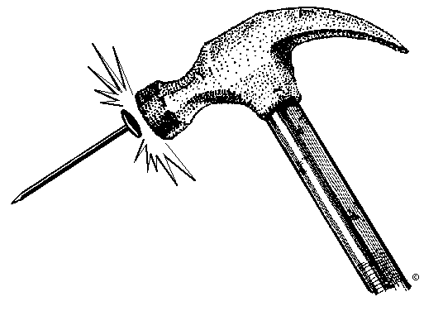 | Address list/Contacts File
Keep a professional mailing list:
Windows: Microsoft Outlook CONTACTS
Mac: Address Book
Database: Microsoft Access
Google: Contacts

 | Calendar program/ To Do list
Windows: Microsoft Outlook CALENDAR
Mac: iCal
Google Calendar (will synch w/Outlook and others)
31 Boxes, Remember the Milk
 | Photo and digital image skills
 | Basic web skills
 | Promotional materials
Postcards
Business cards
Resume

 | Public speaking skills
Practice. Volunteer.
Join Toastmasters if you have problems with public speaking.

Networking strategies
 | Attitude adjustment
Be friendly and curious about other people. Shy? Develop an art manager persona and do the job well. You can be shy in your personal life, but you need to be a participant for your career.

Offer other people interest, help.

 | Things to do
Volunteer – e.g. being a museum docent, helping w/a fund-raiser, conference volunteer, community-based things (murals at schools, fund-raising walks, community-based college service organizations like Circle K Camp.).
Donate work
Go to openings, lectures, and professional events and talk to people. It’s often easier if you have a job to do, e.g. being a volunteer.
Meet people at professional events and offer something
Be a studio assistant at a summer or community program
Take a summer or community class at “art camp” programs – scholarships/work-study often avail. The Painter’s Edge, Skowhegan, Penland, Arrowmont, Haystack Mountain School, Chautauqua

Become a resident artist http://penland.org/programs/resident_artists.html
http://www.skowheganart.org/
This gives you a new network group. Places that sponsor residencies often will promote their artists. MANY art centers offer residencies. Do an online search.

Join professional groups and go to conferences
National Council on Education for the Ceramic Arts
Society for Photographic Education
Southern Graphics
Museum memberships

Learn helpful skills and share them (Word, web, business cards, photo, resume, etc.). Other people will reciprocate.

Participate: announce shows and openings (bragging is different than participation – get over false modesty and realize that you are your own agent), participate on discussion lists, offer demos at public events. Start crit nights, drawing groups, etc.
Join alumni groups.

Develop a peer network. You don’t have to know everything yourself. It helps to have a network of people who know helpful things, and for people to know your skills and abilities about which you are willing to give advice or help.

Develop contacts with suppliers if appropriate. Offer images that use their products or to give demos and workshops pro bono. While having work featured in a supplier catalog is not a high art credential, it helps people become familiar with your name and your work.

Offer to do pro bono local workshops and demos to arts groups, community colleges, at galleries and art events, etc. Take a sign-up for your mailing list when you go.

Tell people you meet what you do.

Pass on interesting information to people you know who would be interested.

 | Web presence
Web site that reflects the content of your work and you can keep updated
Post web content that brings people to your site: share other artists you find, tutorials, research, videos of demos and you in action, show opps,
http://debuse-on-the-loose.blogspot.com/
http://lindaarbuckle.com/arbuckle_links.html
http://lindaarbuckle.com/arbuckle_handouts.html

Facebook presence for your art identity

Blog http://carterpottery.blogspot.com/feeds/posts/default

Sell work online
Etsy http://www.etsy.com/shop/kiefferceramics?order=&section_id=&page=1

Start a social group online for peers in your interest group http://spruz.com/
http://artaxis.org/index.html

Start a library of work for teaching or find one and help
http://accessceramics.org/

Develop an announcement list (your work, show or residency opportunities in your field, ???). This can be done through a web host, as a group online (Google groups), or a service like MailChimp (free for smaller lists) http://www.mailchimp.com/

 | Things to avoid
 |  | T.M.I. – Too Much Information: separate your private life from your public professional art life. Do NOT post those on-the-edge party pictures of yourself on Facebook. Do not discuss partying. If your friends post such things about you, ask them to remove the image, or remove your name from them. Employers often do internet searches on prospective hires. Create a nom de plume if you want to post personal info online. Check your Facebook privacy settings, but be aware that posting something on the internet is basically a public act. Consider what you would look at if you were hiring. PC World has had some online articles about Facebook and privacy issues.

