Learning to Use Color
by Linda Arbuckle
printed in Studio Potter magazine, v. 35, no.1, an issue on color in ceramics. (http://studiopotter.org/ )

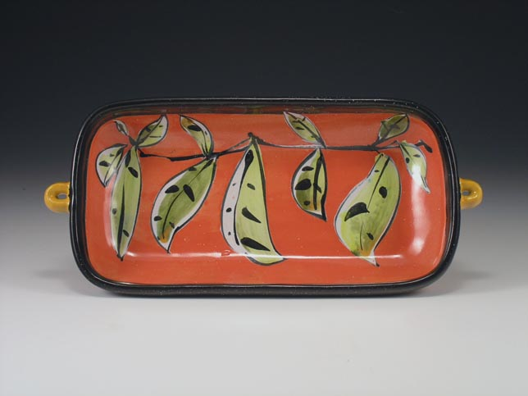
We live in a world where color is taken for granted. Black-and-white pictures or movies are very intentional events in the twenty-first century, while big-screen color is everywhere. The World Wide Web allows people to broadcast images across the globe, cheaply and in color. Inexpensive inkjet printers output color documents in a rainbow of hues. Fiber dyes give us clothing and textiles in shades not seen in the 1900S. We assume color and color choice in products as the status quo, but learning the use and significance of color is often overlooked, or assumed to be an intuitive talent. Making effective color choices is a skill that demands observation, thought, and practice.
Using color in ceramics is an exercise in restraint. The color that can be achieved in the studio is wonderful, but it is fraught with special rules that rival "I before E except after C, or when sounded like A as in neighbor and weigh." The technical and chemical aspects of colorant-flux interaction make ceramic color more complex than mixing paint. There are few WYSIWYG (what you see is what you get) opportunities in ceramic process; changes in firing make composing color during glazing an exercise requiring experience and pre-visualization, as well as a benevolent nod from the kiln gods. The bonuses are the variety of surfaces, color variations, depth of color, and reflectivity that are difficult to achieve with room-temperature surfaces: the glory of minute trapped bubbles in a frosty Chun glaze, the wonder of a bead glaze, the tactility of a lichen surface.
How does a clay artist proceed to develop a communicative and personal use of color? The first rule, I think, is to work in series. The more you like the form, and the fewer of them you have to work with, the more conservative you become in surface decisions.
For sculptors, this might mean doing a series of small maquettes or representative fragments of a larger work, surfaced and fired as the large work will be. For potters, it means making more than you think you need of a particular form in order to allow yourself to investigate beyond the first ideas and safe choices. I have confidence that most people will not bore themselves by repeating exactly the same thing, but will invent new options once they exhaust the first, evident ideas. As Joe Bova has often said, "Some work makes more work," meaning that you're more likely to get new ideas when things are in progress. Having many pieces to work with allows for the inevitable failures that are part of any creative growth process, and provides more chances to find the better options.
Rule two: the copy machine is your friend. It helps to draw the form whose surface you are considering, copy that drawing a dozen times, and color it in to see alternative choices for hue and value placement, and where and how that moves the eye. Do these yourself, or solicit efforts from other people. Sometimes knowing what doesn't work puts you further on the road toward what you do want. It's all helpful. Put all the options up on the wall, pull up a chair, and have a viewing. We are usually better as editors than creators. It's much easier to look at options and select the ones that do and don't work than to imagine one right solution.
Rule three: while the exercise in rule two helps you understand your intuitions and inner visions and how those might manifest themselves, there is no substitute for seeing the real, fired surfaces. Make test tiles that you can sort, overlap, recombine, so that you have actual examples of your surface palette to look at.
I subscribe to several fashion and interiors magazines as color resources. They have a changing, seasonal zeitgeist of color and proportion, and often interesting composition in ads. The big value is that they have many, many colors in them, and I'm not at all precious about cutting out swatches and looking at them in combination. The amount and relative position of each color changes every-thing, as Josef Albers showed us in his color studies. Color swatches from the magazines offer me cheap ways to experiment and respond to visual examples with little commitment. I may not have glazes exactly like those colors, but it gets me thinking and I find new ideas.
Philip Rawson's classic book, Ceramics,
is a must-read for clay artists. He is a "chewy" writer, so I like reading my paperback copy with a highlighter to pick out nuggets of information. Rawson discusses the visual interpretation of color associations, cultural context, surface reflectivity, and so many other helpful things. It's a bonus that he's opinionated, and you can find places to disagree with him. Raising the questions and heightening sensitivity are of value in them-selves.
In addition to classic color books by people like Itten and Albers, there are many contemporary books, including those for people who want to decorate their interiors. I've found several flip books of floor, wall, and ceiling combinations that have reinforced the importance of adjacent colors and values, and contributed to my understanding of color mood and intonation. Certainly books for painters are helpful. Consideration in figurative reference of emotional vs. literal color is often brought up.
Finally, a sketchbook and some kind of color medium (crayons, pencils, watercolor, markers), used to sketch from the real world in color, helps the artist to see better. It's not about making a lovely drawing as a product, but about the very important exercise of really seeing the myriad things that we pass by every day.

